Secure File Transfer Between Two CentOS Linux Virtual Machines
Objective
Transfer files securely between two CentOS virtual machines using:
- SCP (Secure Copy)
- RSYNC (Remote Synchronization)

Lab Setup
Machine | Hostname | IP Address | Username | Role
VM 1 | server.local | 192.168.100.10 | gora | Server (Receives Files)
VM 2 | client.local | 192.168.100.20 | atul | Client (Sends Files)

STEP 1: Create Two CentOS Virtual Machines
Create two VMs in VMware.
VM 1
- Hostname: server.local
- User: gora
VM 2
- Hostname: client.local
- User: atul

STEP 2: Configure VMware Network
Power off both VMs.
Go to:
VM → Settings → Network Adapter
Select Host-Only (Recommended)
or
NAT (if both VMs can communicate)
Enable:
- Connected
- Connect at power on
Start both VMs.

STEP 3: Set Hostname
Server VM
sudo hostnamectl set-hostname server.local
Client VM
sudo hostnamectl set-hostname client.local
Reboot both VMs.
sudo reboot

STEP 4: Check IP Address
On both VMs
ifconfig/ ip a
Example
Server
192.168.100.10
Client
192.168.100.20
Note: The IP addresses must be different.

STEP 5: Test Connectivity
From Client
ping 192.168.100.10
From Server
ping 192.168.100.20
Expected Output
64 bytes from 192.168.100.xx
This means both machines can communicate.

STEP 6: Install SSH Server
Run on both VMs (or at least on the server VM).
sudo yum install openssh-server -y
Start SSH
sudo systemctl start sshd
Enable SSH
sudo systemctl enable sshd
Check Status
sudo systemctl status sshd
Expected
active (running)

STEP 7: Allow SSH in Firewall
sudo firewall-cmd --permanent --add-service=ssh
Reload firewall
sudo firewall-cmd --reload
Verify
sudo firewall-cmd --list-services
Output should include
ssh

STEP 8: Create Folder on Server
Login to Server VM
mkdir /home/gorakh/hello
Verify
ls /home/gora
Output
hello

STEP 9: Create Files on Client
Login to Client VM
touch file1.txt
touch file2.txt
touch file3.txt
Verify
ls
Output
file1.txt
file2.txt
file3.txt

PRACTICAL 1: SCP (Secure Copy Protocol)
What is SCP?
SCP is used to securely copy files between Linux machines using SSH.
Syntax
scp filename username@server_ip:destination
Example
Run on Client VM
scp file1.txt user@192.168.65.130:/home/user/hello
Enter the password of user gora.
Example
gora@192.168.100.10's password:
File Transfer Complete.
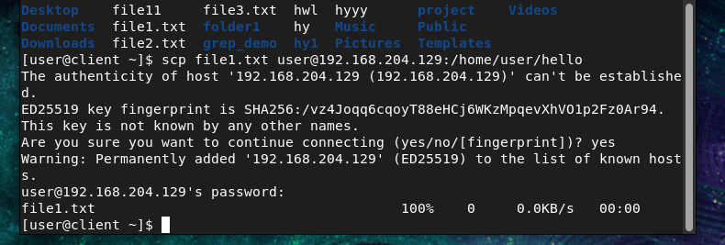

Verify on Server
ls /home/gora/hello
Output
file1.txt

Copy Multiple Files
scp file1.txt file2.txt file3.txt user@192.168.65.130:/home/user/hello

scp file*.txt user@192.168.65.130:/home/user/hello

Copy Entire Directory
Create a directory
mkdir project
Create files
touch project/test1
touch project/test2
Transfer
scp -r project/ user@192.168.65.130:/home/user/
Verify
ls /home/gora/project

scp -r user@192.168.65.130:/home/user/hello .

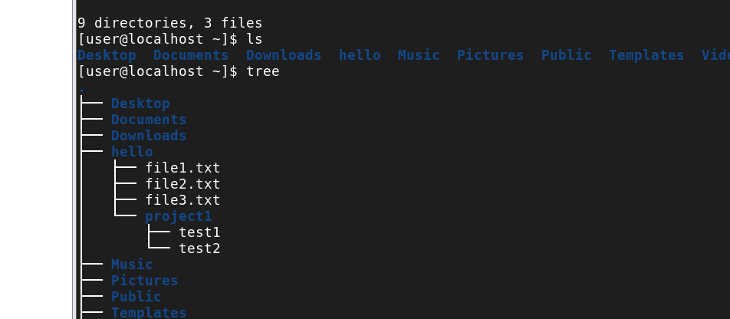

PRACTICAL 2: RSYNC
What is RSYNC?
RSYNC synchronizes files between two Linux machines.
Unlike SCP, it copies only the changed parts of a file after the first transfer.

Step 1: Create a File on the Client
echo "Linux" > notes.txt
Check the file:
cat notes.txt
Output:
Linux

Step 2: Send the File Using RSYNC
rsync -av notes.txt user@192.168.65.130:/home/user/hello/
Output:
sending incremental file list
notes.txt

sent 120 bytes
received 35 bytes

total size is 6
Now check on the Server:
cat /home/gora/hello/notes.txt
Output:
Linux
The file has been copied successfully.

Step 3: Modify the File on the Client
Append one line:
echo "Red Hat" >> notes.txt
Check it:
cat notes.txt
Output:
Linux
Red Hat

Step 4: Send the File Again
rsync -av notes.txt gora@192.168.100.10:/home/gora/hello/
Output:
sending incremental file list
notes.txt

sent 125 bytes
received 35 bytes
Now check on the Server:
cat /home/gora/hello/notes.txt
Output:
Linux
Red Hat
Notice that the file was updated.
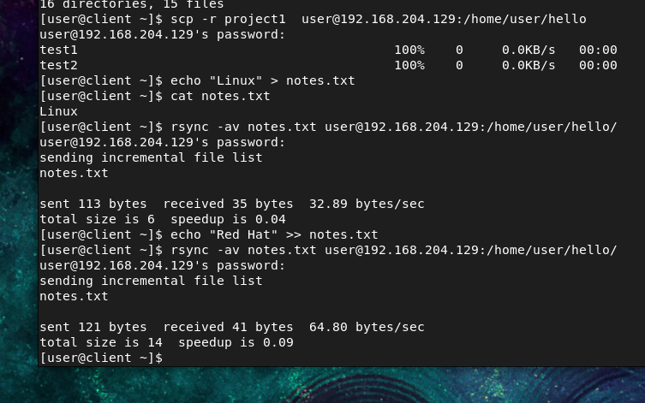

How Does RSYNC Know What Changed?
Suppose your file is:
Line 1 : Linux
Line 2 : CentOS
Line 3 : VMware
You change it to:
Line 1 : Linux
Line 2 : Rocky Linux
Line 3 : VMware
Only Line 2 changed.
When you run rsync again:
- SCP sends the entire file again.
- RSYNC compares the old and new file and sends only the changed block (the part containing "Rocky Linux").
This is called delta transfer.

